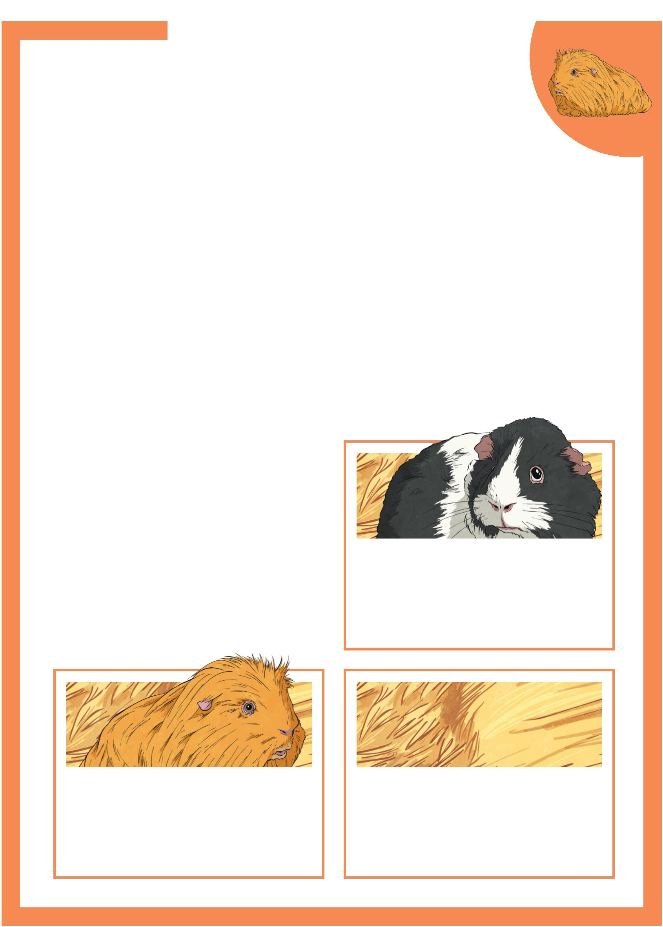Pet Care of a Guinea Pig
Guinea pigs are small mammals with short legs and no tail.
They originally come from South America.
Diet
Guinea pigs need to eat food like hay to give them fibre. This helps
them digest their food.
Guinea pigs should have vegetables and some types of fruit every day but only
in small amounts.
Lemons and limes can make them ill so remember not to give them those fruits.
Environment
Guinea pigs need a large area like a hutch so that they have room to explore.
They should have a safe, warm, dry
area where they are away from other
pets.
The temperature must be comfortable.
If it gets too hot, they can get heat
stroke.  Guinea pigs must be in a quiet place.  Noises make them scared. |  | Did You Know?  Guinea pigs are active for up to 20  hours a day!
Did You Know? Did You Know?
Guinea pigs cannot climb or dig Their teeth grow all the time so
but do like to go down tunnels! they need to chew hay. This wears
their teeth down.
Page 1 of 2

Pet Care of a Guinea Pig
Guinea Pig Behaviour
Guinea pigs need lots of exercise. They like to
run through tubes and pipes.
They are prey animals so get scared. When this
happens, they will freeze and be totally still.
They can see all around themselves, so they can  see when they might need to escape! |  | Guinea Pig Signs  of Stress:
• overgrooming;
Guinea pigs need to live in pairs or small groups.
• chewing the bars of They get very unhappy if they are on their own.
the cage;
They need to get used to being picked up so they
• drinking a lot of need to be with adults and children.
water.
Dangers to Guinea Pigs  • Grass that has been cut by the lawnmower  can make them ill. |  | Take your guinea pig  to a vet if it is showing  these signs.
• Bedding that can be pulled apart can cause
problems for guinea pigs. They might eat it which is very dangerous.
• Other animals can frighten guinea pigs. Keep them away.
Page 2 of 2

Pet Care of a Guinea Pig
Questions
1. Where do guinea pigs come from?
2. What do guinea pigs need to eat?
3. What sort of hutch do guinea pigs need to live in and why?
4. What could happen if a guinea pig gets too warm?
5. Give one example of something guinea pigs like to do?
6. What part of them grows all the time?
7. What do guinea pigs do when they are scared?
8. Name one thing a guinea pig might do if they are stressed?
9. What can make guinea pigs upset?
10. Describe what sort of bedding a guinea pig needs.

Pet Care of a Guinea Pig
Answers
1. Where do guinea pigs come from?
Guinea pigs come from South America.
2. What do guinea pigs need to eat?
Guinea pigs need to eat hay and some fruit and vegetables.
3. What sort of hutch do guinea pigs need to live in and why?
A guinea pig needs a large hutch to have room to explore.
4. What could happen if a guinea pig gets too warm?
If a guinea pig gets too warm, it can get heat stroke.
5. Give one example of something guinea pigs like to do?
Guinea pigs like to go down tunnels/ be active.
6. What part of them grows all the time?
Their teeth grow all the time.
7. What do guinea pigs do when they are scared?
When they are scared, guinea pigs freeze and are totally still.
8. Name one thing a guinea pig might do if they are stressed?
A guinea pig might: overgroom themselves, chew the cage
bars, drink too much water. (Accept any one)
9. What can make guinea pigs upset?
Guinea pigs can get upset if they are left on their own with no other guinea pigs.
10. Describe what sort of bedding a guinea pig needs.
A guinea pig needs bedding which does not break oﬀ into strands.

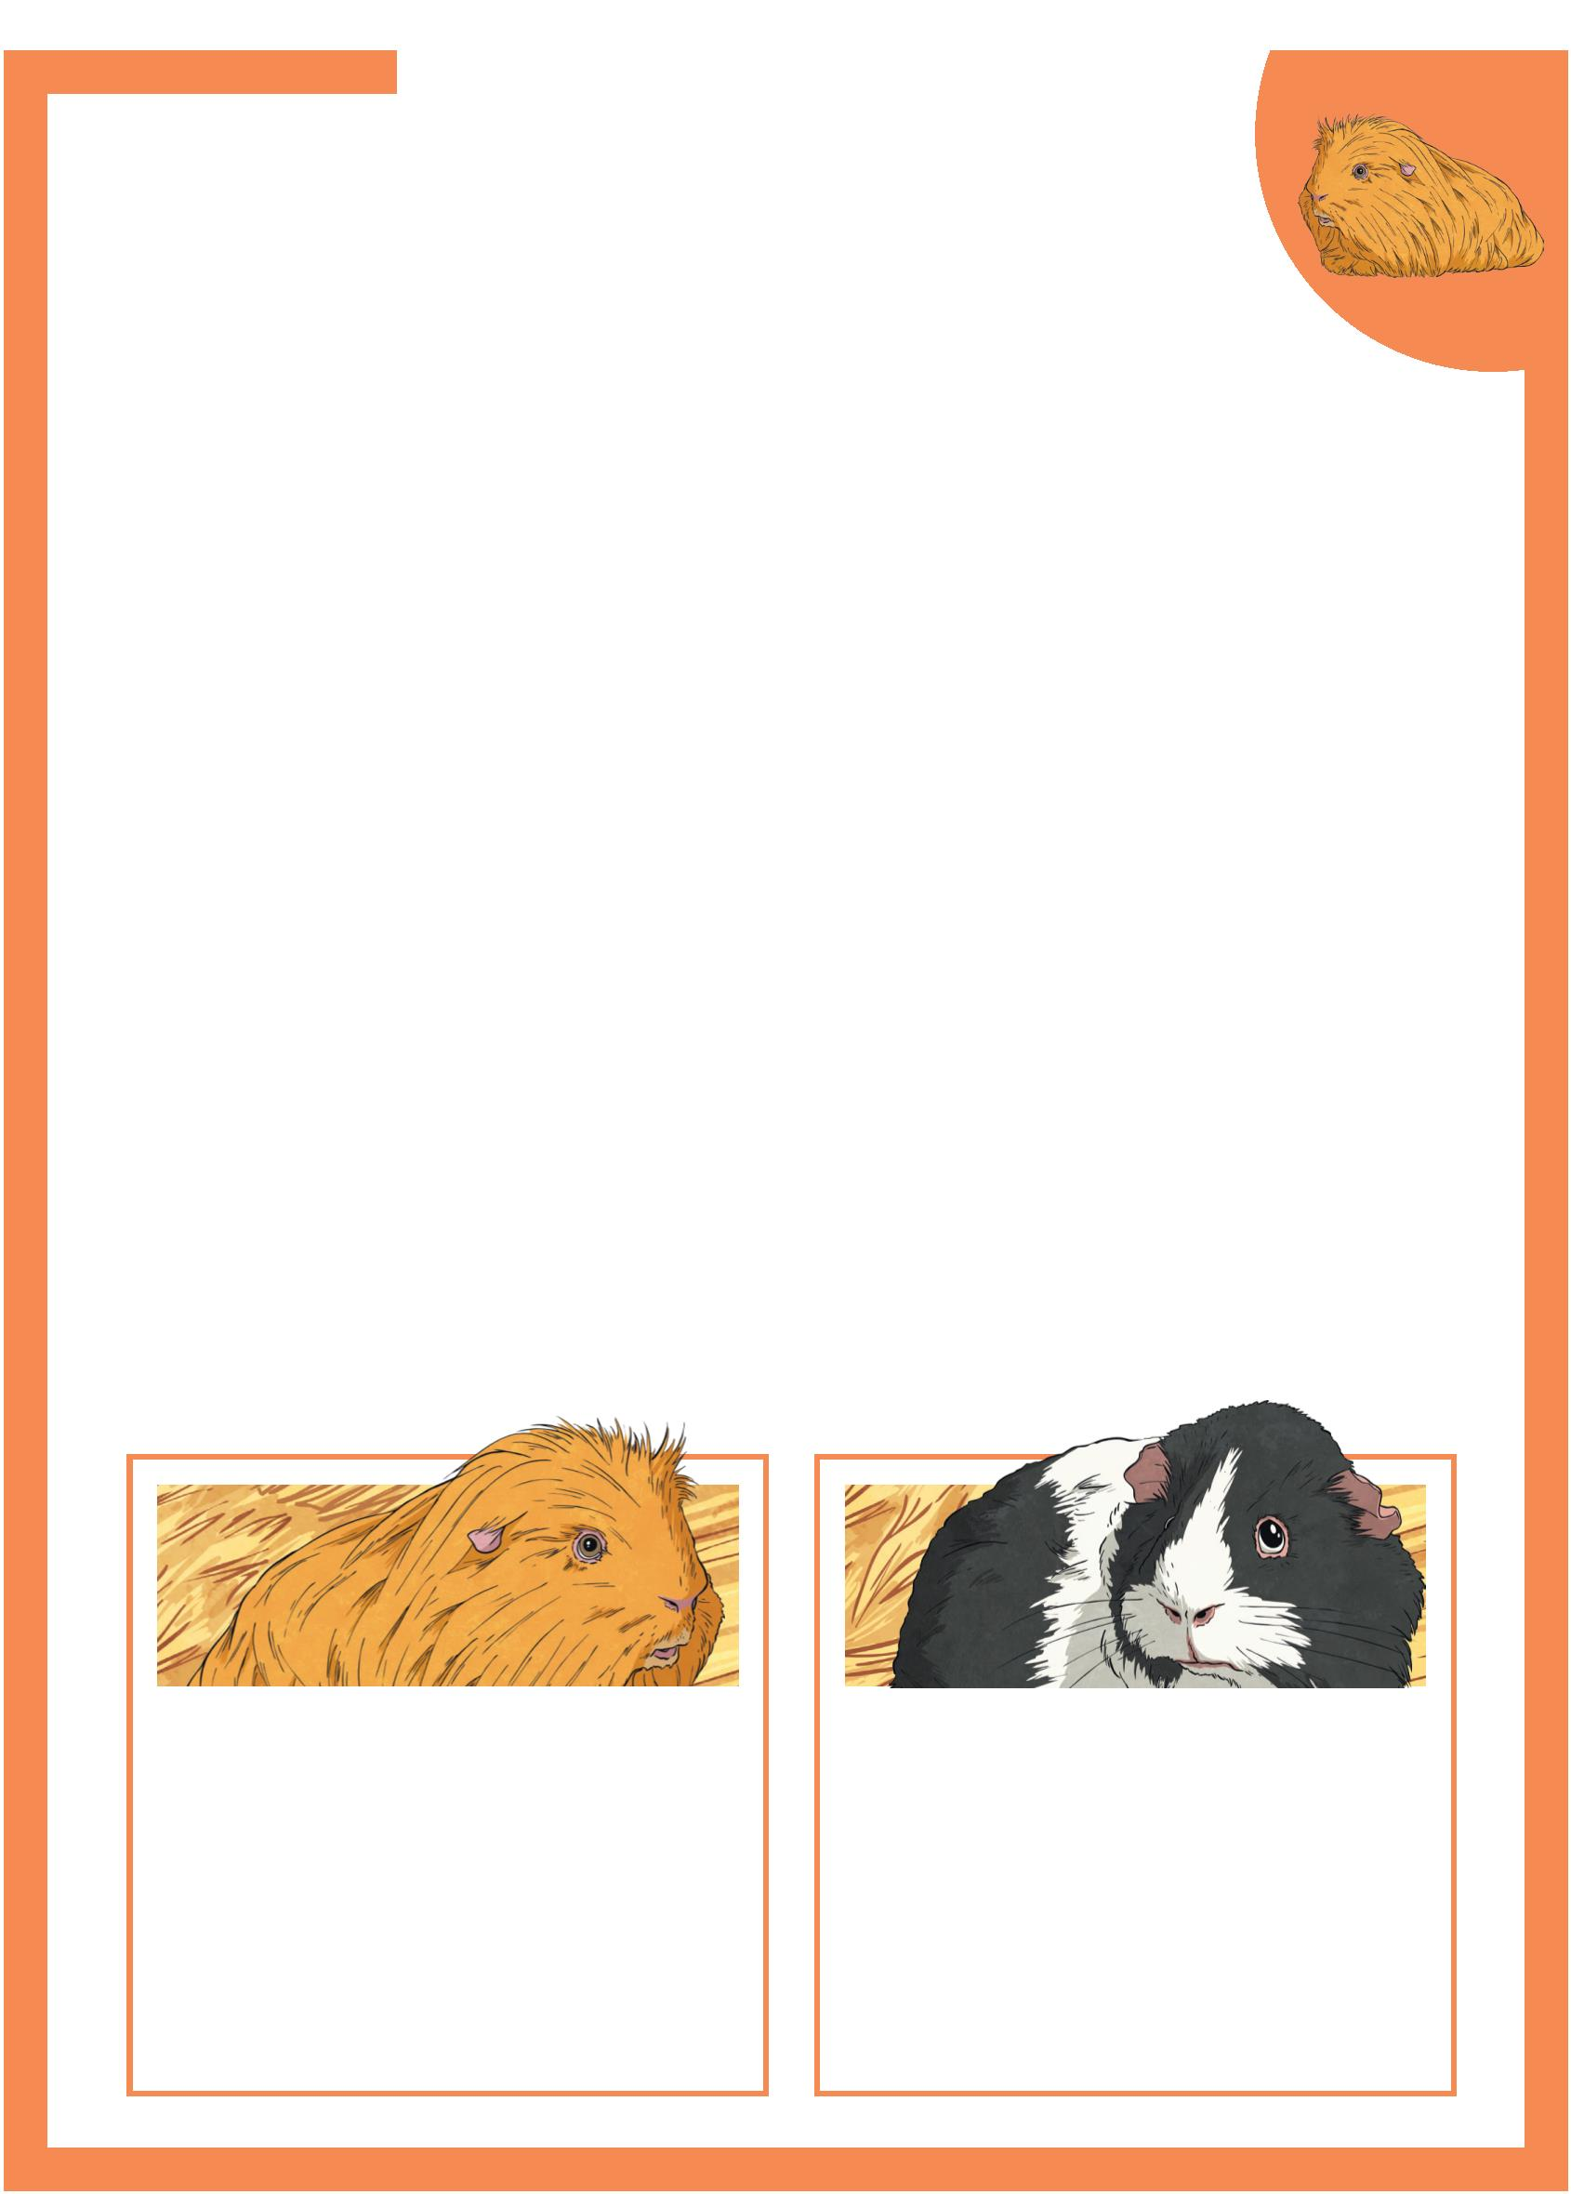Pet Care of a Guinea Pig
Guinea pigs are small mammals with short legs and no
tail. They originally come from the grasslands of the Andes
Mountains in South America and are an important food source
in that region.
Diet
Guinea pigs need a high fibre diet because of the way they digest their
food. Good quality hay helps their digestion system work properly. They also
need grass based pellets high in Vitamin C. Their bodies are not able to store
Vitamin C so they need to have it in their food, regularly.
Guinea pigs should have daily vegetables like broccoli or kale, and some fruits,
but only in small amounts. They should never have fruits like lemons or limes,
and neither have many root vegetables, like carrots. These foods can make them
ill if eaten in large amounts.
Environment
Guinea pigs need a large area like a hutch, where they can explore and stand on
their back legs when they want to.
They should have a safe, warm, dry and clean area where they are away from
other pets, and safe from foxes and ferrets.
The temperature must be no warmer than 26°C as they can suffer with heat
stroke, and anything colder than 15°C can give them a chill.
Guinea pigs must be in a quiet area as noises can make them scared.
Did You Know? Did You Know?
Guinea pigs make different Their teeth grow all the time so
sounds for a range of reasons. they need to chew hay. This wears
For example, when they are their teeth down.
missing a companion, enjoying some attention or when they get
excited.
Page 1 of 2

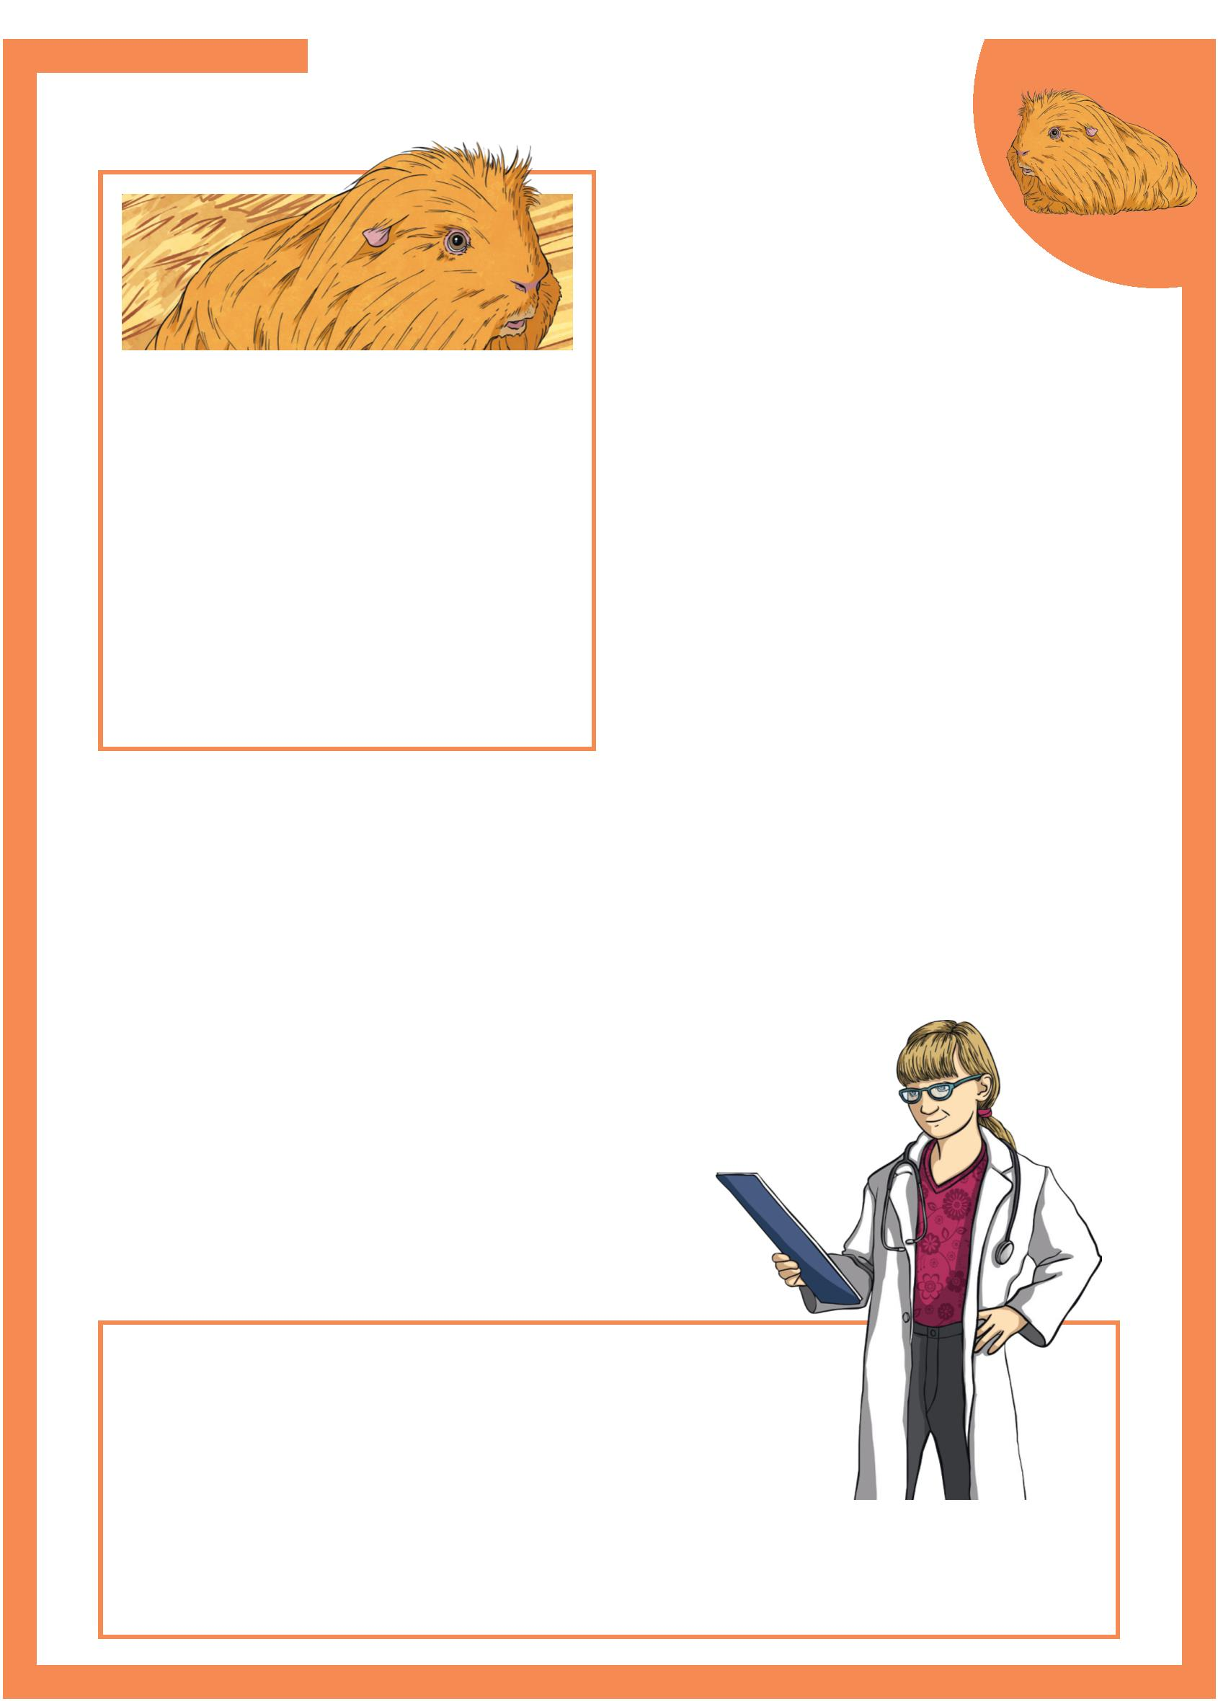Pet Care of a Guinea Pig
Guinea Pig Behaviour
Guinea pigs need regular exercise. They
 | Did You Know?  When guinea pigs are born, they  are already furry, have their  eyes open and can eat solid food |  | like to run through tubes and  pipes. Guinea pigs cannot climb or  dig but do like to be able to hide in  burrows and shelters.
straightaway! They still have They are prey animals so are easily
their mother’s milk for a further 3 scared. When this happens, they will
weeks though. freeze for seconds or minutes. They can
see all around themselves so they can
see when they might need to escape!
Guinea pigs are naturally sociable
animals and need to live in pairs or small groups. They become very unhappy if
they are on their own. Many like contact with people too. They need to get used
to being picked up so the earlier they are with adults and children the better.
Dangers to Guinea Pigs
• Don’t be tempted to give guinea pigs grass that has been cut by a lawnmower.
It can cause problems with their digestion.
• Make sure they don’t have bedding that
can be pulled into strands, like cotton wool.
Guinea pigs can get tangled up in it, which
can be dangerous.
• Make sure other animals cannot frighten
them. They are nervous animals.
Guinea Pig Signs of Stress: • overgrooming;
• chewing the cage bars;
 | • over drinking;  • walking around in circles. |  | Take your guinea pig to a vet if  it is showing these signs.
Page 2 of 2

Pet Care of a Guinea Pig
Questions
1. What does it mean when the text says that guinea pigs are “an important food source in
that region”?
2. Summarise the main points in the paragraph wr
3. What sort of foods should they not have, and why?
4. What sort of environment would not suit a guinea pig?
5. What is the most interesting fact you have learned in the ‘Did you know...?’ section and why
6. Name two things guinea pigs are not able to do.

Pet Care of a Guinea Pig Questions
7. How might a guinea pig owner know if their pet is not happy?
8. What does “guinea pigs are prey animals” mean?
9. What is the beneﬁt of being able to see all around, for a guinea pig?
10. Why would being handled by people from an early age, be good for a guinea pig?

Pet Care of a Guinea Pig
1. What does it mean when the text says that guinea pigs are “an important food source in
that region”?
Guinea pigs are “an important food source in that region” means that in
South America, guinea pigs are an important food to be eaten by people.
2. Summarise the main points in the paragraph wr
The main points made in the paragraph wr
guinea pigs need high ﬁbre food to help their digestion work properly,
and food with Vitamin C in it because their body cannot store it.
3. What sort of foods should they not have, and why?
They should not have too many root vegetables or any
citrus fruits, as they can make them ill.
4. What sort of environment would not suit a guinea pig?
The sort of environment which would not suit a guinea pig is: damp, wet, dirty, or
an environment which is near other animals, not safe, and too hot or too cold
5. What is the most interesting fact you have learned in the ‘Did you know...?’ section and why
Pupil’s own response.
6. Name two things guinea pigs are not able to do.
Guinea pigs are not able to climb or dig.

Pet Care of a Guinea Pig Answers
7. How might a guinea pig owner know if their pet is not happy?
A guinea pig owner might know if their pet is not happy, if they see it over grooming,
chewing the bars of the cage, over drinking or walking around in circles.
8. What does “guinea pigs are prey animals” mean?
“Guinea pigs are prey animals” means that they are eaten by other animals.
9. What is the beneﬁt of being able to see all around, for a guinea pig?
For a guinea pig to be able to see all around, it means that they can see a predator
come from behind them, or above them, so they can freeze or escape.
10. Why would being handled by people from an early age, be good for a guinea pig?
It would be good for guinea pigs to be handled by people from an early age because
it would mean they would get used to it and not be scared when being picked up.

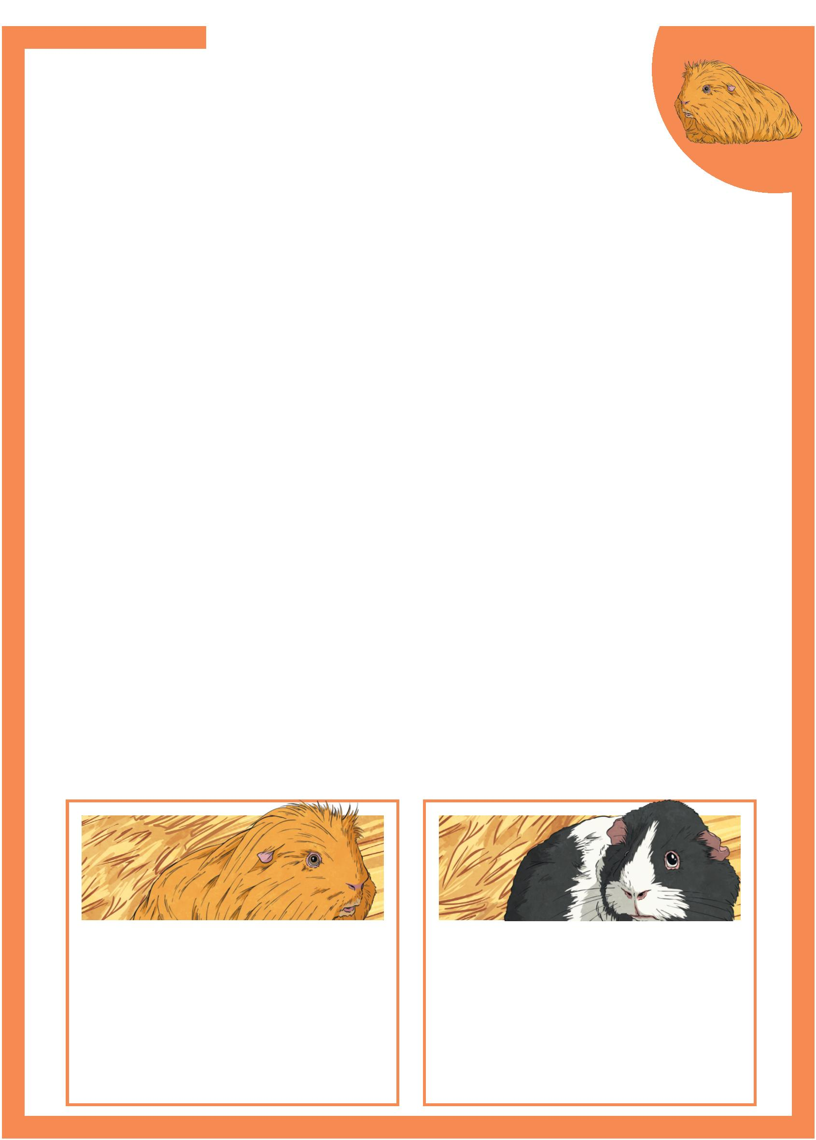Pet Care of a Guinea Pig
Guinea pigs are small, compact mammals with short legs
and no tail. They originate from the grasslands of the Andes
Mountains in South America and are an important food source
in that region.
Diet
Guinea pigs need a high fibre diet due to their unusual digestive system.
They need good quality hay to enable their digestion to function properly and
grass-based pellets high in Vitamin C. They lack a certain enzyme, which would
help store Vitamin C, so need a daily intake of this vitamin.
Vitamin C is vital to ensure proper bone growth and to boost the immune
system to enable defence against germs and illness.
Guinea pigs should have daily vegetables like broccoli and kale, and some fruits,
but only in small amounts. They should not have citrus fruits or too many root
vegetables like carrots. They can become very ill if they have large quantities of
these foods.
Environment
Guinea pigs need a large, spacious area like a hutch, where they can explore and
have room to stand on their back legs when necessary.
They require a safe, warm, dry area where they are away from other pets and
safe from predators.
The temperature must be no warmer than 26°C as they can suffer with heat
stroke, and anything colder than 15°C can give them a chill.
Guinea pigs must be in a quiet area as they can get stressed with noise.
Did You Know? Did You Know?
Guinea pigs’ teeth continue to When guinea pigs are born, they
grow throughout their life so need are already furry, have their
to chew hay which wears their eyes open and can eat solid food
teeth down. straightaway! They still have their
mother’s milk for 3 weeks though.
Page 1 of 2

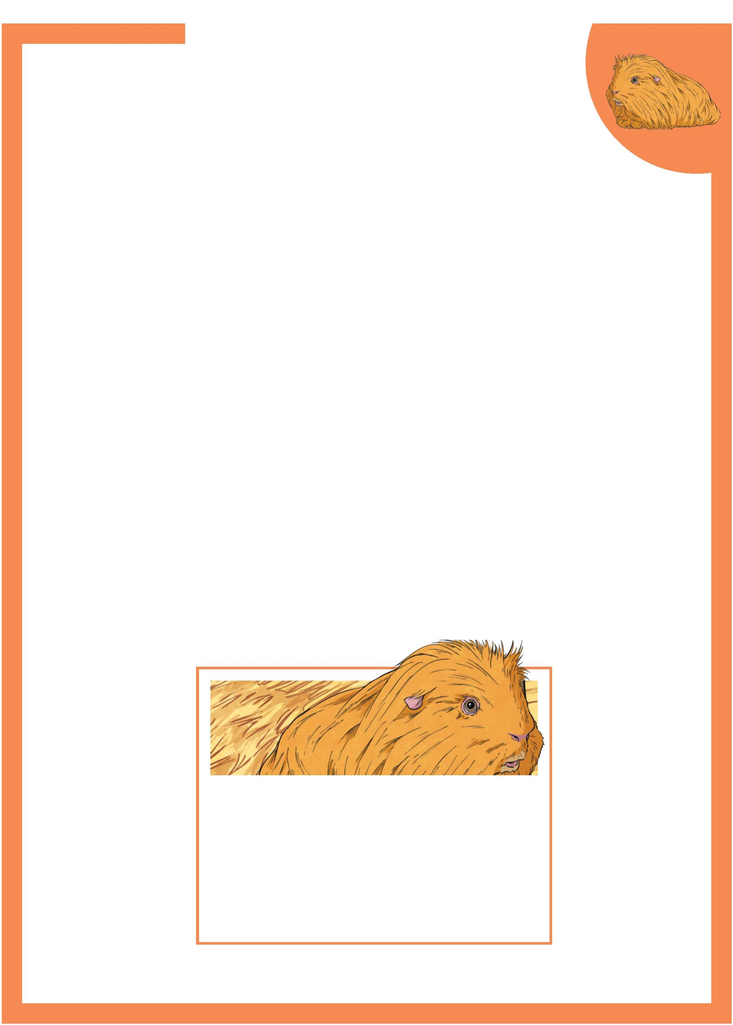Pet Care of a Guinea Pig
Guinea Pig Behaviour
Guinea pigs require regular, interesting exercise. Tubes and
pipes are great for exploration and although they are not
equipped to dig, guinea pigs like to be able to hide in burrows
and shelters.
They are prey animals so naturally nervous and easily scared. When this
happens, they will freeze for seconds or sometimes minutes. They can see above
and behind themselves so they can see a predator in good time to escape!
Guinea pigs are naturally sociable creatures and thrive in pairs or small groups.
They can become very distressed if alone and often respond well to human
company too. They need handling form an early age to become used to people
and children.
Dangers to Guinea Pigs
• Lawnmower clippings can cause problems for their digestive system so never
be tempted to give them these as a treat.
• Nesting material which can separate into strands like cotton wool. The animals
can get tangled up in these strands, or if they eat they can become very poorly.
• Other animals are a threat to the security and safety of a guinea pig. As it is
a prey animal, potential predators need to be kept away.
Did You Know?
Guinea pigs communicate through
making different sounds. For example,
when they are missing a companion,
enjoying some attention or when they get
excited.
Page 2 of 2

Pet Care of a Guinea Pig
Questions
1. What is the purpose of the ﬁrst paragraph? Give as much detail as you can.
2. Guinea pigs need two very speciﬁc foodstuﬀs. What are they, and why are they so
important to a guinea pig?
3. Guinea pigs are not to be given citrus fruits. Name two such fruits.
(Use a dictionary if necessary).
4. Explain why guinea pigs need to be housed in a speciﬁc temperature.
5. Which of the Did you know…? facts surprises you the most, and why?

Pet Care of a Guinea Pig Questions
6. Why are guinea pigs easily scared?
7. How do you think a predator might interpret a guinea pig ‘freezing’ when it senses danger?
8. Look at the paragraph in italics. Summarise the main points in that paragraph.
9. What part of a guinea pig would be aﬀected if it was given mown grass to eat?
10. Imagine you are writing a label describing a guinea pig in a pet shop. In one paragraph,
give the most important information to tell a potential owner about guinea pigs.

Pet Care of a Guinea Pig
Answers
1. What is the purpose of the ﬁrst paragraph? Give as much detail as you can.
The ﬁrst paragraph is an introduction to the text. It explains what the text is about, and
gives some background information about guinea pigs, including what they look like.
2. Guinea pigs need two very speciﬁc foodstuﬀs. What are they, and why are they so
important to a guinea pig?
Guinea pigs need hay because it is high in ﬁbre. Guinea pigs need this to help their
digestive system function properly. They also need grass-based pellets because these
are a good source of Vitamin C. Guinea pigs need Vitamin C to make sure their bones
grow properly and that their immune system works well to ﬁght illness and germs.
3. Guinea pigs are not to be given citrus fruits. Name two such fruits.
(Use a dictionary if necessary).
Two fruits which a guinea pig cannot have because they are citrus fruits are: lemons,
limes, grapefruits, satsuma, oranges, tangerines, nectarines. (Accept any two).
4. Explain why guinea pigs need to be housed in a speciﬁc temperature.
Guinea pigs need to be housed in a speciﬁc temperature because
if they get too warm, over 26°C they can get heat stroke, and
if they are too cold, below 15°C, they can get a chill.
5. Which of the Did you know…? facts surprises you the most, and why?
Pupil’s own response.

Pet Care of a Guinea Pig Answers
6. Why are guinea pigs easily scared?
Guinea pigs are easily scared because they are prey animals. This means
they are nervous incase a predator comes along and eats them.
7. How do you think a predator might interpret a guinea pig ‘freezing’ when it senses danger?
I think a predator might think the guinea pig is dead,
or not see it properly because it is so still.
8. Look at the paragraph in italics. Summarise the main points in that paragraph.
The main points in this paragraph are: guinea pigs need to live
with other guinea pigs; guinea pigs get lonely on their own; guinea
pigs need to be handled by people from an early age.
9. What part of a guinea pig would be aﬀected if it was given mown grass to eat?
If a guinea pig was given mown grass to eat, it would
aﬀect its digestive system/ stomach.
10. Imagine you are writing a label describing a guinea pig in a pet shop. In one paragraph,
give the most important information to tell a potential owner about guinea pigs.
Pupil’s own response.

